AI ASSISTED CODING

LAB-7.4

NAME: G.HARISH

ENROLL NO: 2403A52073

BATCH:04

**TASK :01**

Introduce a buggy Python function that calculates the factorial of a number using recursion. Use Copilot or Cursor AI to detect and fix the logical or syntax errors.

**PROMPT:**

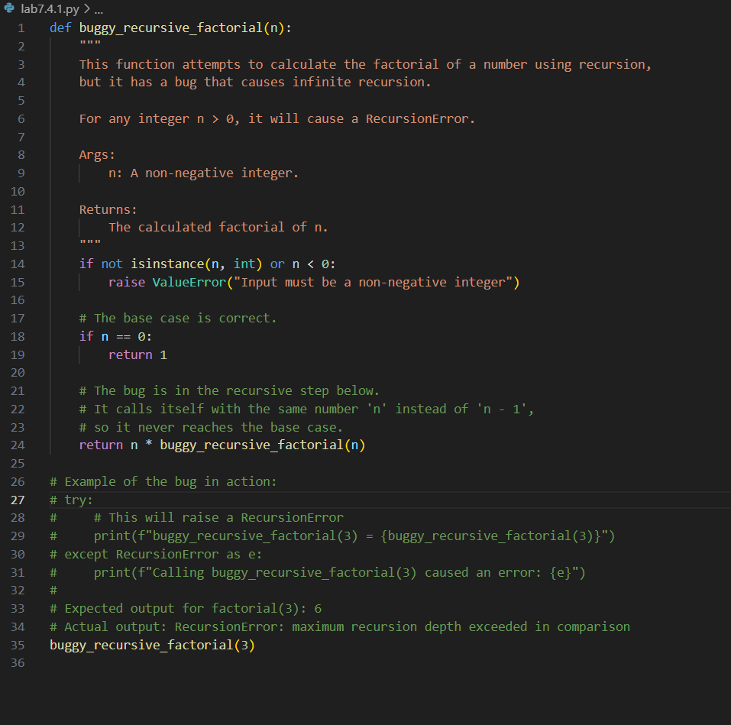

Detect the bugs in the code and correct it .

**CODE:**

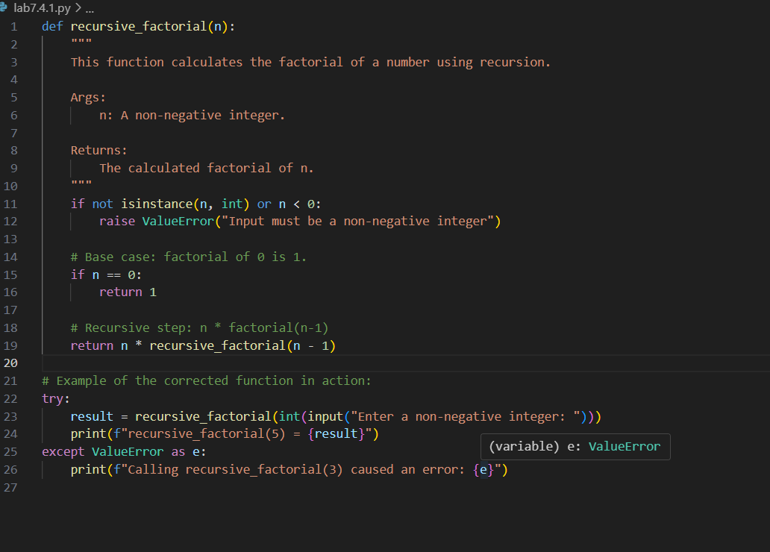

**OUTPUT:**

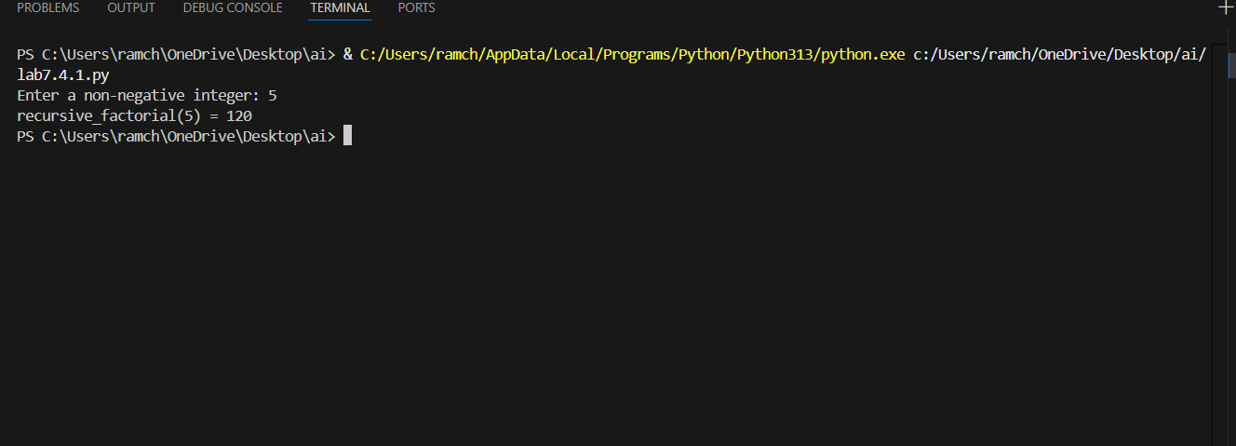

**OBSERVATION:**

The given prompt code has bugs which are resolved by the AI and rewrite the code.

**TASK :02**

Provide a list sorting function that fails due to a type error (e.g., sorting list with mixed integers and strings). Prompt AI to detect the issue and fix the code for consistent sorting.

**PROMPT:**

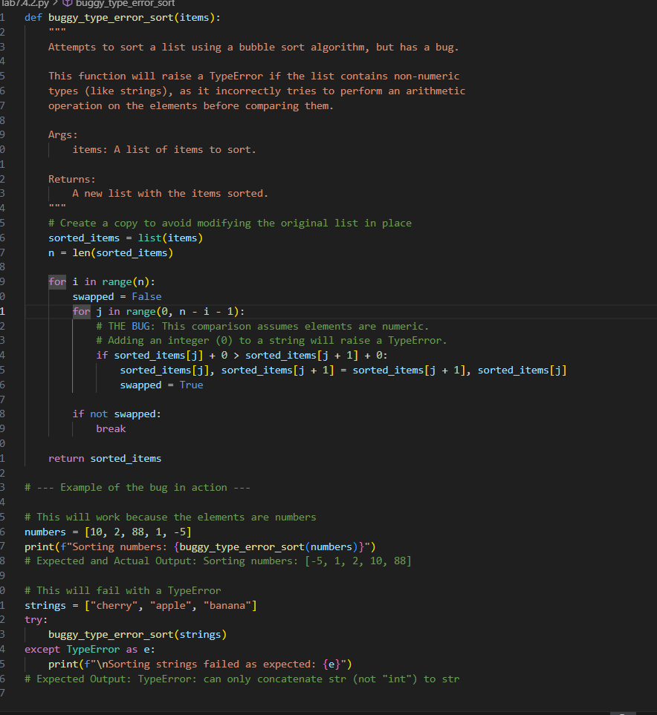

Detect the issue in the code and correct it.

**CODE:**

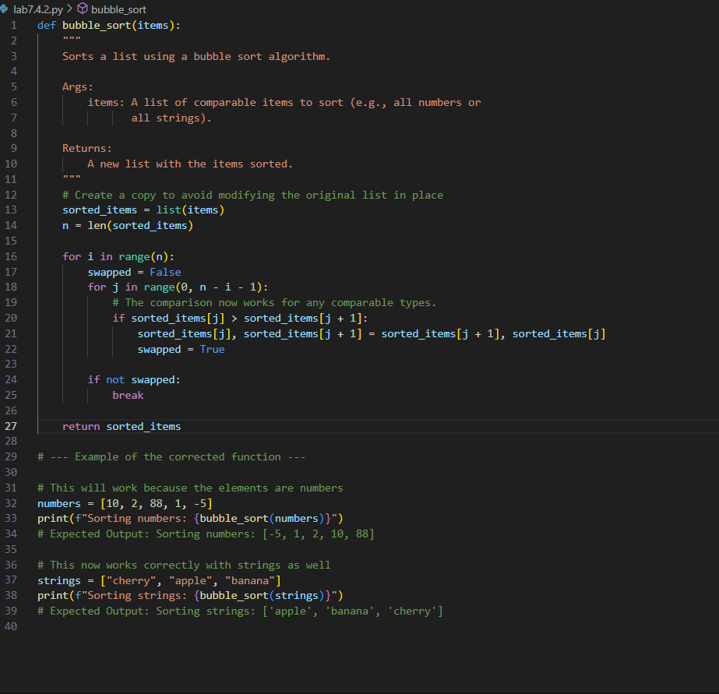

**OUTPUT:**

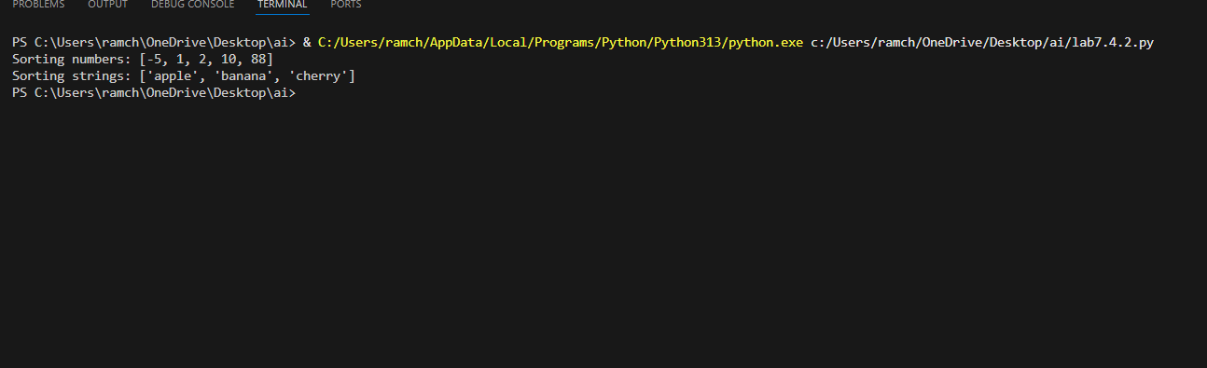

**OBSERVATION:**

The code has a bug of not sorting the list of names lexographically it only sorts the list of numbers in ascending order whereas in the code given by gemini has both the ability.

**TASK :03**

Write a Python snippet for file handling that opens a file but forgets to close it. Ask Copilot or Cursor AI to improve it using the best practice (e.g., with open() block).

**PROMPT:**

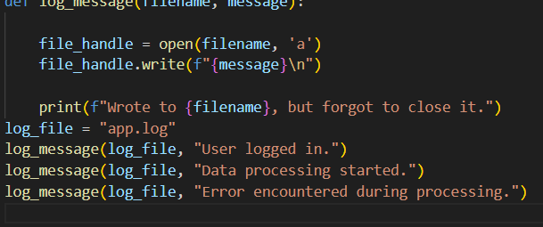

Detect the bug and correct the code.

**CODE:**

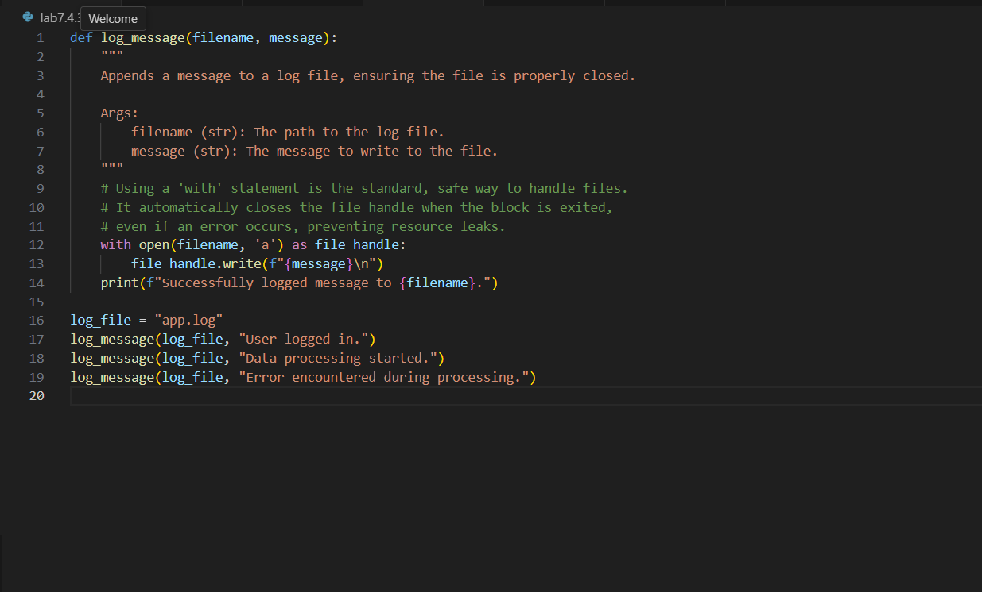

**OUTPUT:**

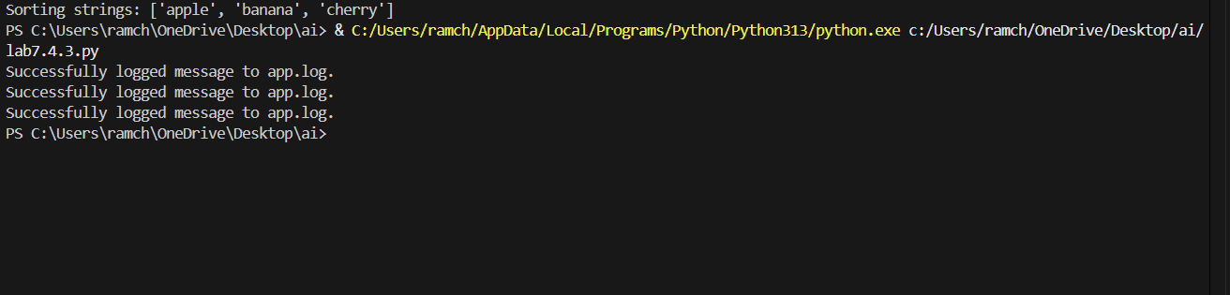

**OBSERVATION:**

The bug in the code is it opens a file to store some data btu forgots to close it. The bug is resolved by the AI

**TASK :4**

Provide a piece of code with a ZeroDivisionError inside a loop. Ask AI to add error handling using try-except and continue execution safely

**PROMPT:**

Generate a python code to perform the ZeroDivisionError and include try-except methods to improve the efficiency of the code.

**CODE:**

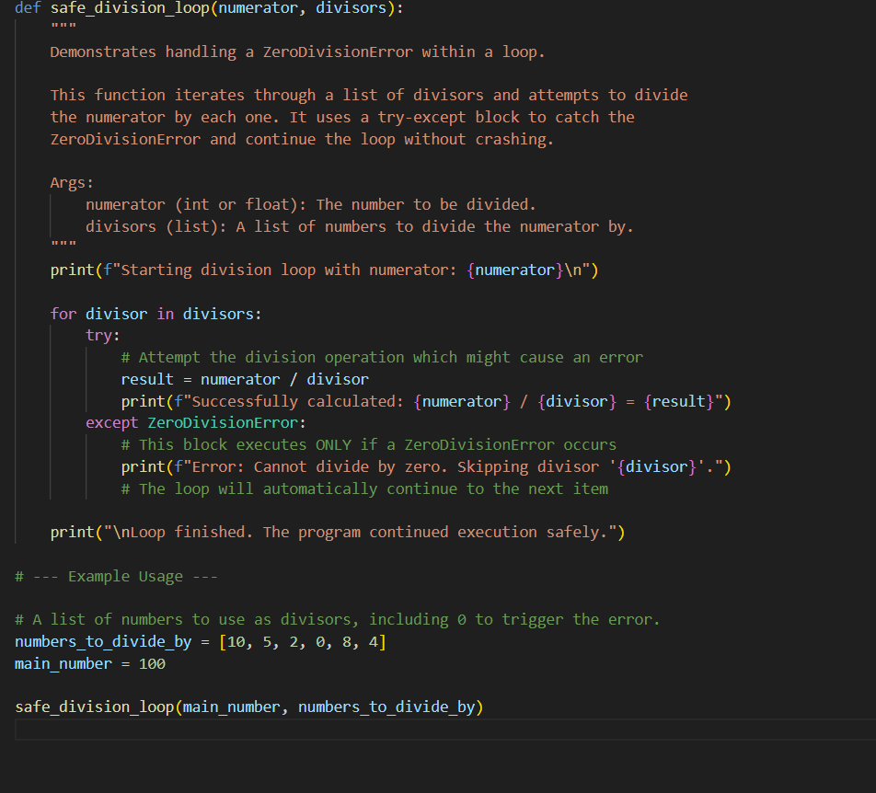

**OUTPUT:**

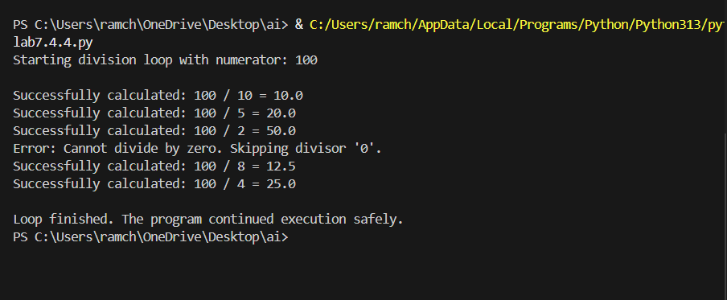

**OBSERVATION:**

The code generated by AI has the ability to perform the operations like ZeroDivisionError and giving an efficient output.

**TASK :05**

Include a buggy class definition with incorrect __init__ parameters or attribute references. Ask AI to analyze and correct the constructor and attribute usage.

**PROMPT:**

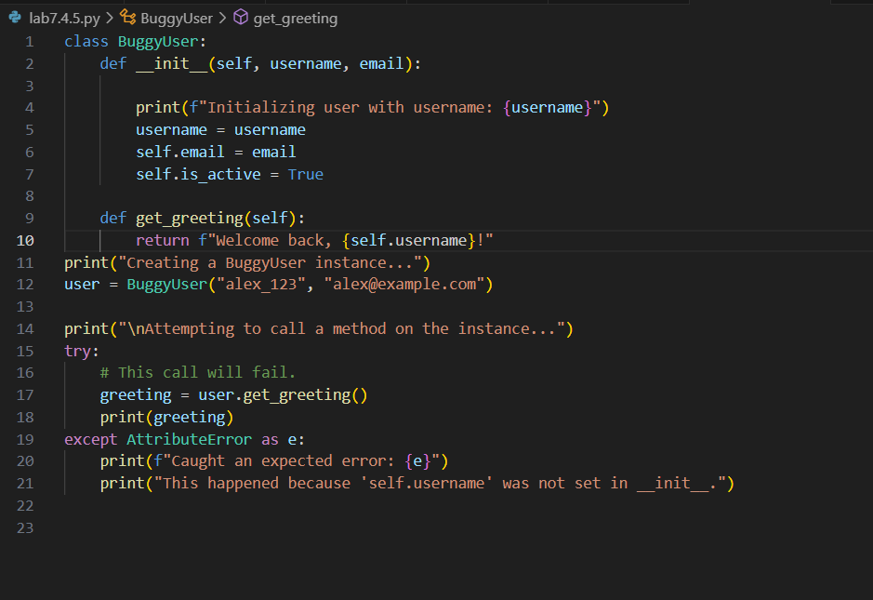

Detect the bug in the code and rewrite the correct code with the correct class.

**CODE:**

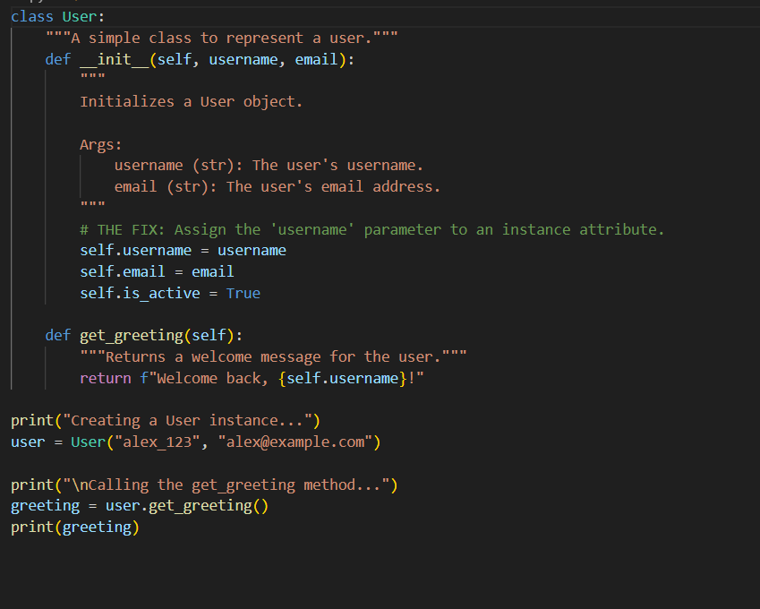

**OUTPUT:**

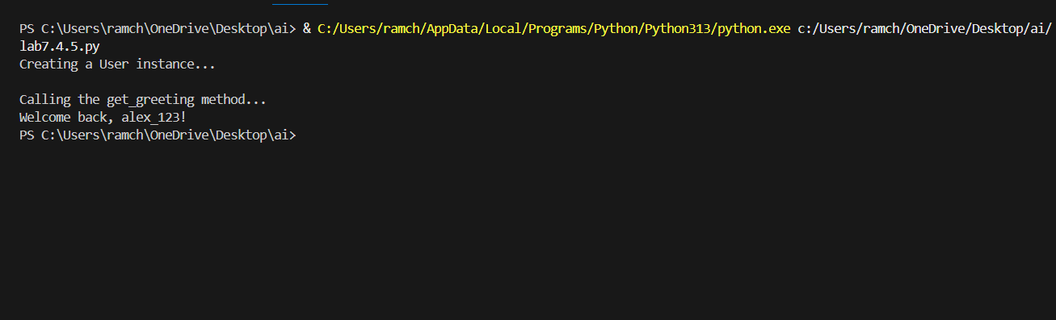

**OBSERVATION:**

The AI has efficiently corrected the bugs in the code provided by the user and gave the debugged code.